St George’s CE Primary School, Chorley

Music Policy

Adopted by the Governing Body on: July 2024
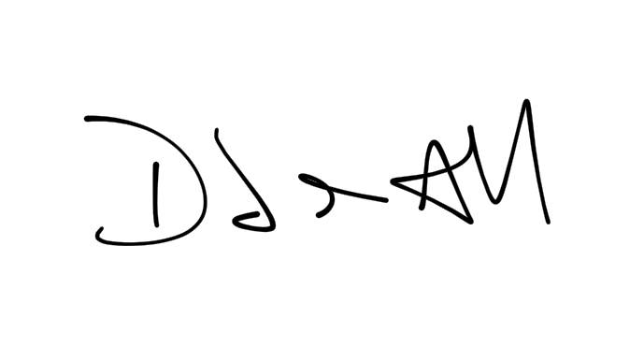
Signed (Chair of Governors):

Date of Next Review July 2025
(not more than 12 months from the publication date)

This document is available via the school website or from the school office on request

Contents

Intent | Page 3
Implement | Page 5
Impact | Page 7

Intent

What is the school’s mission statement?

"Be determined and confident, as God will be with you, inspiring us to learn, care and share through work, play and prayer."
What is the school’s vision for the subject?

AIMS

- To enable each child to grow musically at his/her own level and pace, and to foster a sense of enjoyment in music.
- To foster musical responsiveness, and develop a sensitive, analytical and critical response to sound in general, in particular to those organised patterns of sound called music.
- To offer aesthetic experience and growth as essential parts of human development.
- To assist each child to develop positive self-esteem, and develop social skills and awareness through making music together.
- To develop the capacity to express ideas, thought and feelings through music some of which cannot easily be verbalised.
- To develop the necessary skills and concepts acquired through organising and exploring sounds.
- To offer pupils opportunities to experience the personal satisfaction and self-confidence derived from striving after the highest possible standards, whilst engaged in musical activity.
- To develop an awareness of musical tradition and developments from a variety of cultures, times and places.

How was the curriculum for the subject designed? (Including statutory requirements)
“Music is a universal language that embodies one of the highest forms of creativity. A high-quality music education should engage and inspire pupils to develop a love of music and their talent as musicians, and so increase their self-confidence, creativity and sense of achievement. As pupils progress, they should develop a critical engagement with music, allowing them to compose, and to listen with discrimination to the best in the musical canon.”

The music curriculum in our school has been developed through discussion with consultants from the Lancashire Music Hub. We did this to ensure full coverage of the national curriculum expectations across all Key Stages and so that we have implemented a scheme that can still be tailored to the needs of our children; including provision for EYFS, SEND and rapid learners. The curriculum has been designed so that our children get to experience a wealth of different types of music from around the world and from different eras in time to enhance their cultural capital.

As well as through the national curriculum all children are offered the chance to take part in many other musical lessons and activities throughout their time in school.
These include:
- Weekly hymn practices and daily hymn singing in worships
- Choir
- Ukulele
- After school violin and guitar lessons.

How is our curriculum aspirational for all pupils including those with SEND and more able?

Music is important for children who have special educational needs and we aim to develop the musical potential and aspirations of every child.

Music knows no barriers and it can reach the mind and body of every child whatever their abilities. Awakened to the joys of music, a child can take the enjoyment and experience of music throughout their life.

At St George’s all children with SEND are fully included in the music curriculum and the lessons and musical experiences are tailored fully to suit their individual needs.

Where can the long term, and/ or medium term plan be found?

Long term planning is available on the long term plans. Medium and short term planning stems from the Lancashire Charanga planning and teachers are able to amend this scheme to suit the needs of the children in their class.

Implement

How is the subject implemented in the Early Years Foundation Stage?

In line with the EYFS statutory framework, our children are encouraged to express their thoughts, feeling and ideas through expressive arts including music. As such children in foundation stage are included in the Charanga scheme of work which has units that are “supported by weekly lesson plans and assessment and has a cross curricular/topic-based focus and a musical focus that will allow the teachers to engage the children in activities related to the developmental events taking place in their changing lives”.
Children in EYFS have access to weekly Music lessons where they gain hands on experience with different instruments and are introduced to the basic skills and vocabulary. Children in EYFS sing everyday as part of the learning and are encouraged to find the beat of music regularly.

What professional development is offered to staff in relation to the subject?

We have regular YTSA training sessions with other schools in our alliance which all teachers attend. These sessions are delivered by Lancashire consultants. The Subject Leader is also in regular contact with the Lancashire Music Hub and delivers feedback from CPD to the headteacher and to the staff body as a whole in staff meetings. The subject leader meets regularly with staff to offer support and guidance in using the Charanga scheme, maintains stock of musical equipment in school, buys in new resources and organises extra training for those staff who request/require it.

What resources are used to support the planning of the subject? (schemes of work etc)

Charanga is a complete scheme of ready-made music lessons. The whole scheme has been introduced in St. George’s School for the children to receive a thorough and progressive grounding in music, during their weekly class music lessons.

All the musical elements or concepts as enumerated in the National Curriculum are covered thoroughly.

The children will be continually experiencing these elements as they take part in the enjoyable fundamental musical activities of singing, playing, composing and listening.

Charanga adapted its scheme in 2021 to follow the Model Music Curriculum.

https://www.lancashiremusichub.co.uk/site/

How is learning sequenced to build on prior learning and prepare children for the next stage in their education?

Charanga follows a spiral scheme which is “built around the Interrelated Dimensions of Music: pulse, rhythm, pitch, tempo, dynamics, timbre, texture, structure and notation”. Therefore as the children move through school they are consistently reviewing, embedding and deepening their knowledge across these 9 key areas of music. Subject Leader reviews the long term plans across school, including mixed age classes to ensure there is full coverage of skills and knowledge.

What resources are available to support the implementation of the subject?

Resources are kept in the little classroom, or the breakfast club room. Please return all resources in a tidy fashion, and any resources that are lacking please report to the music subject leader.

How are parents involved in the subject?

Parents of children who are working at greater depth in the subject area of music will be contacted by the class teacher, and signposted to specialist music provision. Children who are entitled to pupil premium funding are encouraged to attend the specialist music provision.
There are many events such as concerts, performances and plays throughout the year (Christmas Carol singing, ukulele concert etc) that parents are invited to attend and enjoy. Parents are also encouraged to upload musical achievements outside of school to SeeSaw so that their child can be encouraged and praised within school for their efforts. Likewise, music lessons are put on SeeSaw by the class teacher and parents encourage their child by leaving a comment on the post or speaking to their child when they get home.

Impact

How is progression helping children to acquire new skills and know and remember their learning?

Skills are taught and built upon over a period of time; once a unit is completed the skills are then revisited and embedded in other units and when the children move up the school.

What are pupil attitudes to this subject, how are they gathered and how does pupil voice influence subject development and improvement?

Subject leader asks children to complete pupil questionnaires once a term; these are then reviewed and discussed with staff. Where appropriate, the suggestions are then implemented in lessons and children can experience that their input and assessment is impactful on their learning.

How do children record their learning?

Whole school implementation of SeeSaw means that not only can teachers record the students’ progress, but children can record their own work and self-evaluate their learning.

How is feedback given to children?

Feedback is given in lesson by class teacher or music teacher, and comments can be given on SeeSaw for any work uploaded by the children.

How and when is the subject assessed?

Teachers assess music at the end of each unit from observations in lesson and through any work on SeeSaw. The class teacher identifies any children working below and above the expected standard and this assessment is then used to inform planning of the next unit and signposting to extra tuition and support.

How do assessments impact future learning?

Lessons are adapted to fit the needs of the children. If there are misconceptions teachers are able to revisit a lesson or use supplementary resources. Assessments at the end of the year are passed up to the receiving teacher who is able to adapt the learning in music to suit the needs of the children in their from the earliest opportunity.

How and when is the curriculum map reviewed?

Subject leader reviews and updates the whole school music curriculum overview and also examines the long term plans of individual classes annually. This is to ensure full coverage of the music curriculum across the school. During this process teachers are encouraged to give their feedback and, alongside the subject leader, make changes to the curriculum map to suit the changing needs of the children.

