
Autumn 1 – Year 5 Home Learning Menu
Maths
- Keep practising times tables on TT Rockstars
- Practice related facts, ready for your weekly test (e.g. 2x5=10 so 20x5=100)

English
- You will be sent weekly spellings to learn every week which will be test on the following Friday.
- Read your school reading book every day to an adult. Remember to record what you read in your reading record to earn certificates.

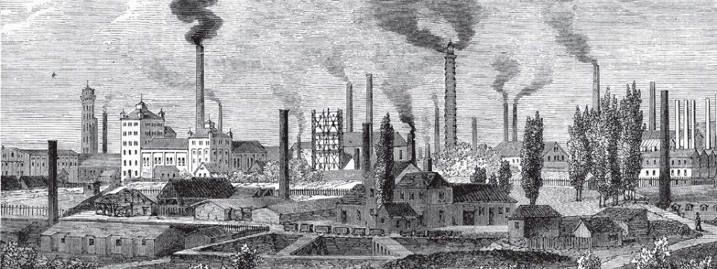
R.E
- In your homework book:
  - Explain how you know the Bible is a special book
  - Find out about special/favourite books for your family. Why are they special to them?
You must:
- Complete all the core activities (Maths, English, one RE activity and one Science activity).
- Select a minimum of 1 other topic activity to complete. You can choose which activity you find the most interesting or be creative and generate your own!
HOMEWORK DUE: Monday 20th October
CELEBRATION DATE: Friday 21st October

French
- Log onto LanguageNut at home using the passwords in your Digital Resource Booklet. See if you can reach the top of the leaderboard!
History
- Create a model of an invention from the Industrial Revolution. You could make a train, a sewing machine, a spinning jenny…
- You could use LEGO, playdough, lollipop sticks, papiermaché…
- Take a photo of this and put it on SeeSaw or bring it in for us to display!
Art and Design

- Create a painting of your street or our school in the style of LS Lowry. Don’t forget the matchstick men!

Science
- Find and carry out some investigations about forces.
e.g. make different paper aeroplanes and see how far they can fly. How can you change the shape to reduce the air resistance?
Record your results. You could do it as a table in your book or as a Newsround report on Seesaw.
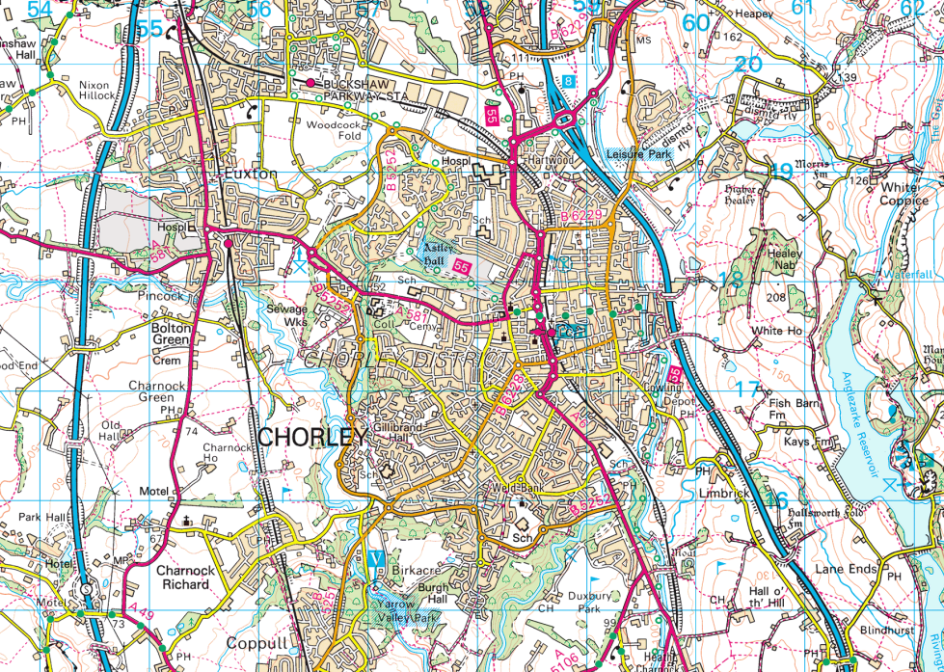

Chorley – present day

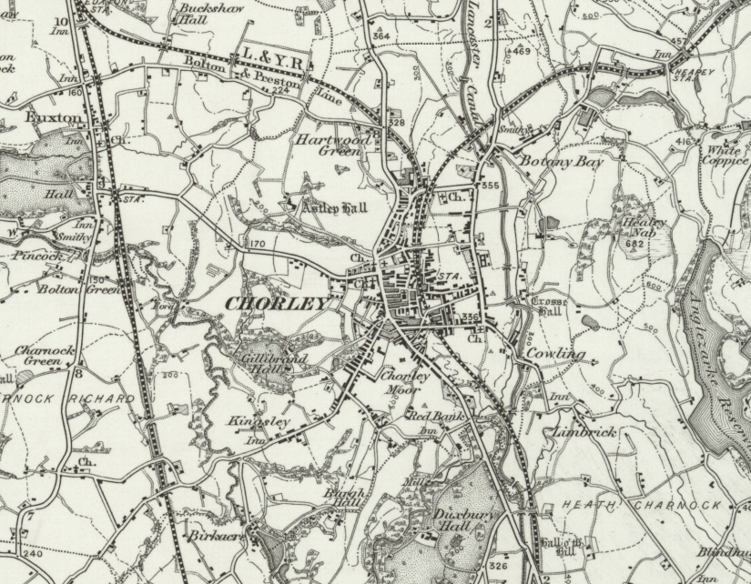

Chorley – 1890

